**Anti-ARP system to detect, prevent and recover from Man-in-the-Middle attacks**

by

Jani Krish 18BEC1010

Madhav Chaturvedi 18BEC1036

Nithesh chowdary 17MIS1098

Devadattan 17MIS1105

A project report submitted to

**Prof. ANUSHA K**

**SCOPE**

In fulfilment of the requirements for the course of

**CSE3502 – INFORMATION SECURITY MANAGEMENT**

In



**Vandalur – Kelambakkam Road Chennai – 600127**

**BONAFIDE CERTIFICATE**

Certified that this project report entitled “**Man-in-the-middle, DNS spoofing and DOS attack using ARP cache poisoning and its prevention”** is a bonafide work of **Jani Krish– 18BEC1010, Madhav Chaturvedi – 18BEC1036, Nithesh Chowdary -17MIS1098 and Deva dattan – 17MIS1105** who carried out the project work under my supervision and guidance for **CSE3502 – Information Security Managment**

**Prof. Anusha K**

SCOPE

VIT University,Chennai

**ABSTRACT**

In this project, the method to perform various man-in-the-middle attacks is shown in a controlled environment. These attacks are performed using various virtual machines on a single system. The attacks shown are ARP poisoning, DOS and DNS spoofing. A single point of failure of all the three attacks are identified and a rudimentary python script to detect and prevent these attacks is also created and tested under different conditions and the results are noted. This script mainly revolves around the fact that if a single MAC address corresponds to two different IP entries in the ARP cache, then it can be said that the cache is poisoned. For preventing undesired changes in the ARP cache, all the entries of the cache are changed into static entries, as a result these cannot be automatically changed even if anyone sends unsolicited ARP replies.

*Keywords – Man-in-the-middle, ARP, spoofing, DOS, DNS.*

# ACKNOWLEDGEMENT

We wish to express our sincere thanks and deep sense of gratitude to our project guide, **Anusha K.,** Professor, SCOPE, for her consistent encouragement and valuable guidance offered to us in a pleasant manner throughout the course of the project work.

We also take this opportunity to thank all the faculty of the School for their support and their wisdom imparted to us throughout the course.

We thank our parents, family, and friends for bearing with us throughout the course of our project and for the opportunity they provided us in undergoing this course in such a prestigious institution.

|  |  |  |
| --- | --- | --- |
|  | **TABLE OF CONTENTS** |  |
| **SL.**  **NO.** | **TITLE** | **PAGE NO.** |
| 1. | ABSTRACT | 3 |
| 2. | ACKNOWLEDGEMENT | 4 |
| 3. | INTRODUCTION | 6 |
| 4. | RELATED WORKS / LITERATURE REVIEW | 7 |
| 5. | PROPOSED WORK | 8 |
| 6. | EXPERIMENTAL SETUP (HARDWARE & SOFTWARE SPECIFICATIONS ) | 12 |
| 7. | EXPERIMENTAL RESULTS DISCUSSION | 13 |
| 8. | CONCLUSION AND FUTURE WORK | 15 |
| 9. | REFERENCES | 16 |
| 10. | APPENDIX 1 (Code) | 17 |
| 11. | APPENDIX 2 (Execution steps and screenshot of outputs ) | 18 |

**INTRODUCTION**

In this project, detailed instruction to perform various man-in-the middle attacks are discussed. The attacks are simulated in a controlled environment using virtual machines hosted on a single system. The attacks discussed are ARP cache poisoning to get username and password of users, DOS (Denial of Service) and DNS(Domain Name System) cache poisoning.

All these attacks require both the victim and the attacker to be in the same Local Area Network. This is because in a LAN, the systems communicate with each other using MAC addresses instead of IP addresses. To make this communication faster, every system in that LAN stores a cache of various IP addresses in the network along with its corresponding MAC address. This cache of IP and MAC is called an ARP cache. Thus the Address Resolution Protocol (ARP) is used to provide mapping between the Network Layer and the Data Link Layer.

By successfully performing an ARP cache poisoning attack, the attacker will be placed between the victim and the gateway, as a result all the victim’s traffic will pass through the attacker. The attacker can now stop, modify or allow the packets to pass. If the packets are not encrypted, then the attacker can view all the information in the packets including confidential information like username and password. If the attacker blocks all the victim’s packets, then the victim will be unable to access the internet which is a denial-of-service (DOS) attack. The attacker can also choose to send fake DNS replies to the victim which makes the victim redirected to any website as wished by the attacker. There are a lot of dangerous man-in-the-middle attacks which require ARP poisoning as the first step of the attack. So we can say that ARP poisoning is the single point of failure in all these attacks, and theoretically, by solving the problem of ARP poisoning, we can solve all the other man-in-the-middle attacks.

For detecting and preventing ARP poisoning attacks on the victim’s system (not the gateway), we have created an application using python called anti-arp. This is capable of detecting and preventing potential ARP attacks just by analysing the ARP cache of the system. The fact that static ARP entries cannot be changed automatically is used to prevent ARP poisoning by attackers.

# RELATED WORKS / LITERATURE REVIEW

With the current rise of Software-Defined Networking (SDN) and Service Function Chaining (SFC), these networking technologies are opening new doors for vulnerabilities in the field of cyber security, which can be exploited by using trivial methods and past approaches. Hence, detection of such exploitations is necessary considering the use of these technologies in the emerging software industry and their applications. The paper [1] talks about how detection of such exploitations can be done. The paper specifically focuses on ARP Poisoning. The paper tries to exploit the repetitive ARP reply sent by the attacker to detect the respective attack. The paper provides an accurate and subtle solution when compared to other solutions.

This paper [2] gives an in depth view of the ARP poisoning methods and lists down different techniques that can be used to achieve the ARP poisoning for a victim system. A detailed description for implementing the attack has been provided in JavaScript that can be applied to most of the websites. As Man-in-the-middle is the most sorted method to execute an ARP cache poisoning, this paper [3] has presented a method to not only detect the attack but also prevent it. Their method proposes to create an ARP table that contains the replies received from the devices on the network, and to check if all the systems have the same table to verify the authenticity of the data collected. Any unusual behavior in the table would mean that an attack had been implemented, thus detecting the attack. After detection, these replies can be discarded, thus preventing the attack. On the other side, this paper [4] provides a solution that enables authorization for ARP, which was a vulnerability, and added features of detection and preventions of ARP cache poisoning of dynamic IP configuration. To check the pair entry of IP-MAC, a secondary cache is used to implement the internet control management protocol (ICMP). DNS spoofing is one of the many prominent attacks used exploiting the system of a target machine. This paper [5] provides a new approach to DNS Spoofing by creating a fake DNS server and redirecting the requests sent to the Destination IP through a fake DNS server, thus enabling to intercept the messages.

Due to the dependency of DNS on UDP, it becomes an open battleground for Distributed Denial of Service (DDoS) attack. This paper [6] proposes a method to detect and mitigate the DNS spoofing attack for SDNs, by using technologies like CAuth and OpenFlow protocol to manage the packets and the data transferred between the networks. This allows proper surveillance of the data exchanged between the network participants. By the year 2016, where SSLStrip was a tool that showed the vulnerability of HTTPS websites to the world, adding DNS spoofing to the mixture made it deadly for target machines. Hence, this paper [7] suggests a technique that allows the victim to detect the stripping of HTTPS website or a more technical term would be downgrading HTTPS website to HTTP. Thus, allowing the victim to avoid such websites before providing any personal credentials to the attacker who is imposing as the website owner.

Most of the DoS detection methods generally go for making a ping to the website or server, and check if the response has unexpected latency or no response from the server. These signal them as that a DoS attack has been initiated. However, this paper [8] uses an aegis algorithm to find if a specific server or a website has undergone a DoS attack or not. Not only does it detect the attack but it also helps moderate the attack. As DoS attacks have many flavors, one of the types are DoS atomic attacks. Though these types of attacks are classified, the paper [9] somehow tries to present two examples of the atomic DoS attack to give a deeper knowledge of the topic. The paper [10] talks about an optimal method of detecting these DoS attacks with higher precision and notifies the owner, before a considerable damage is made to the server. [11] Provides a method to secure systems against MITM.

# PROPOSED WORK

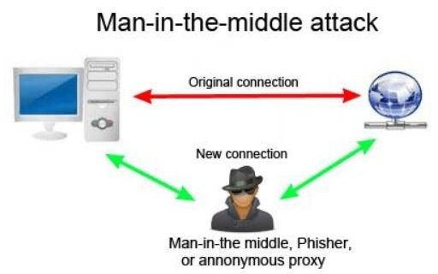

Fig 1: Man-in-the-middle Attack Block Diagram

The aim of this project is to explain what is Man In the Middle attack and demonstrate the various types of MITM attacks namely:-

**A RP Poisoning/Spoofing:-** ARP stands for Address Resolution Protocol is a networking protocol that enables communications in a particular network by linking the network and data link layer. So, ARP spoofing is a type of attack wherein the attacker sends forged APR replies to the victim and as a result, the victim updates its ARP cache with the fake value sent by the attacker, hence the attacker places itself into the communication between the server and the client without any notice of either if the endpoint devices. Hence to demonstrate this ARP attack, we performed an attack to fetch the Username and password which the victim enters on a particular website. The tool used to perform this is ettercap. Ettercap is an open source network security tool for man-in-the-middle attack on LAN.

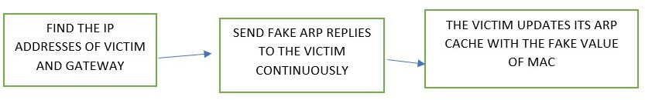

Fig 2: ARP poisoning Block Diagram

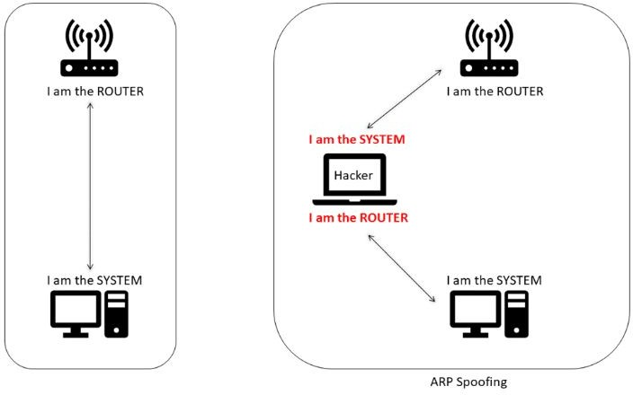

Fig 3: Man-in-the-middle attack visualization

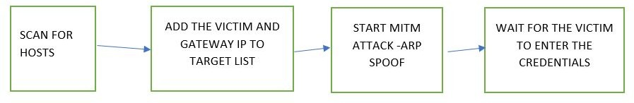

Fig 4: ARP poisoning using Ettercap Block Diagram

**D oS Attack:-** DoS stands for Denial of Service. A DoS attack is an attack that is meant to shut down a particular machine or network hence making it inaccessible to others on the network. This attack is accomplished by flooding the target with traffic or sending some sort of information that triggers a crash. We have tried a non-conventional DoS attack by attacking the user’s system instead of a server. By depriving the victim to send packets, in essence we would have performed a DoS attack on the server side. As a result of this attack the whole of the internet and intranet would not be accessible by the victim. For demonstrating this we performed a simple attack by poisoning the arp cache of the victim with the attacker’s MAC address. Hence we can alter the packet forwarding for the victim to 0, it denies the access of the whole of internet to the victim as all the packets sent by the victim is

being blocked by the attacker. If we set the packet forwarding to 1, and then the victim can access the internet as usual.

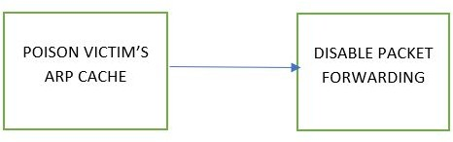

Fig 5: DoS Client side Attack Block diagram

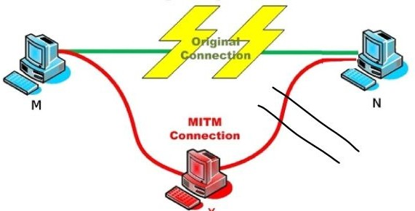

Fig 6: DoS Attack Block Diagram

**D NS Spoof:-** DNS stands for Domain Name Server. So, DNS spoofing is an attack

wherein the attacker can redirect the victim to another website which is not intended to be visited by the victim by injecting a fake DNS record in the DNS cache. As a result of these fake DNS entries, the victim can be redirected to any IP of the attacker’s choosing. This attack can be easily performed in the Kali Linux environment using various inbuilt tools. One such tool that we used is Ettercap. Using ettercap, we first poison the victim’s ARP cache with our MAC address. Then we search for available hosts in the network and add the gateway as TARGET2 and the victim as TARGET1 and start unified sniffing. Finally we add the dns_spoof plugin that is available in ettercap and wait for some time for it to start. Once we get the message that the target website’s DNS has been spoofed, we can check the victim machine and try opening the website in it. We observe that the victim is redirected to some other website even though the address bar says that it is the original website.

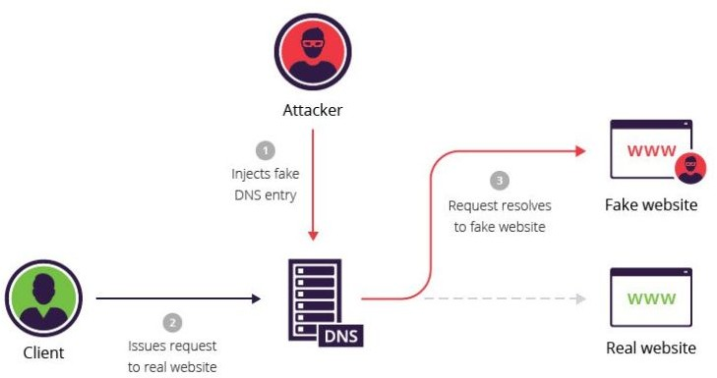

Fig 7: DNS Spoofing Block Diagram

We have also devised an algorithm for preventing, detecting and recovering the ARP poisoning on a particular machine.

1. **D etection:-** The detection mechanism is called anti-ARP, a simple python program

that browses different IP addresses in the ARP cache and checks if any two IP addresses have the same MAC addresses or not. If they have the same MAC address, which means the ARP cache is poisoned. Once the poisoning is confirmed, the user is prompted with a message saying that the ARP cache has been poisoned. Along with this message, the attacker’s MAC address is also displayed.

1. **P:revention -** For prevention, we designed an algorithm and coded it in python. This algorithm does the task of making all the entries in the ARP cache as static because of the fact that they cannot be altered by the attacker once made static. As a result, no matter how many fake ARP replies are sent to the victim, its ARP cache won't be changed.
2. **R ecovery:-** Once we have detected that ARP cache is poisoned, we can execute the recovery algorithm which is also coded in python. The main idea of the recovery process is copying a clean set of entries into the cache or altering a specific entry in the cache. The clean ARP cache entries are stored when the application is started, provided that the cache is cleaned while starting it. If the user knows the MAC address of the gateway, or any other node in the network, they can enter the ARP entry using one of the features of the recovery system.

# EXPERIMENTAL SETUP (HARDWARE & SOFTWARE SPECIFICATIONS)

## Hardware:

* Intel i5-9300H processor
* 8 GB RAM

## Software:

* VMware workstation 15
* ISO file of kali, Ubuntu and windows 7
* Ettercap, arpspoof, setoolkit and browser (included with kali)
* Python 3.7
* Any text editor

# EXPERIMENTAL RESULTS DISCUSSION

We have performed all the attacks and carried out the prevention, detection and recovery mechanisms successfully. We can draw the following inference from each attack:-

1. **A RP spoof (User Id and Password attack):-** In this attack, we scanned for hosts on

the local network and then added the victim as one of the targets and the gateway as the other target on ettercap and started ARP poisoning attack. We observe that the arp cache of the victim is poisoned with the attacker’s MAC address and hence, the attacker acts as the man in the middle who can see and control the packets transmitted in the network to and from the victim. Hence, whenever the victim enters the credentials or any other information, we get all of the information on ettercap. This was tested on demo.testfire.net and the victim’s credentials were successfully captured.

1. **D oS attack:-** In this attack, we are simply poisoning the victim’s ARP cache and

altering the packet forwarding flag in the attacker’s system configuration. As a result, the attacker is placed between the victim and the gateway, and all the packets sent to and from the victim is under the direct control of the attacker. So when we switch off the packet forwarding and ping google.com on the victim’s machine, we don’t see any response i.e the service is denied. Subsequently, if we switch on the packet forwarding and then ping google.com, it works.

1. **D NS Spoofing:-** In this attack, Ettercap plays a very important role in enabling the

ARP spoofing and DNS spoofing. We first scan the network for hosts and subsequently add the victim and the gateway as the targets. In the ettercap config, we enable the commands for Linux as we are working in a Linux based environment. We also used the in-built plugin available in ettercap for DNS spoofing. After waiting for some time, we can see that the victim is redirected to some other website rather than on the original one. When the victim enters their credentials in the fake website, we are able to obtain this information.

We did a bit of research and brainstorming and devised algorithms for detection, prevention and recovery from an ARP spoof attack and coded them in python.

1. **D etection:-** For detection, we implemented a simple searching algorithm to search the

ARP cache of the victim for 2 IP addresses with the same MAC address. If any such entry is found, that means the ARP cache is poisoned. This was pretty straightforward and hence we got the desired outcome.

1. **P revention:-** After researching about the various methods of prevention, we came to a conclusion that any ARP poisoning attack can be prevented just by making all entries in the cache as static. By doing so, we make sure that the attacker cannot further make any changes to the ARP cache by sending fake ARP replies.
2. **R ecovery:-** The main idea of the recovery process is copying a clean set of entries

into the cache or altering a specific entry in the cache. The clean ARP cache entries are stored when the application is started, provided that the cache is clean while starting it. If the user knows the MAC address of the gateway, or any other node in the network, they can modify the ARP entry.

Hence the experiments were successful and we were able to demonstrate the different types of ARP poisoning attacks using inbuilt tools in Kali Linux and programming skills. We were also able to show the prevention, detection and recovery procedures which are essential from an Information Security point of view.

# CONCLUSION AND FUTURE WORK

In this project, we have successfully implemented ARP poisoning, DOS, and DNS poisoning attacks. We have also recorded the procedure and explained it step-by-step in great detail. Even though these attacks have a limitation of only working on LAN, these are very common and easily performed and virtually undetectable by a novice. As a result, this is a threat that has to be addressed. So, we have come up with an app “anti-arp” which is capable of detecting, preventing and recovering from an ARP poisoning attack on the victim’s Linux system. This is written in python and mainly focuses on analyzing the ARP cache of the system to detect attacks. Also there are functions which have the capability of performing continuous scans after a certain regular interval of time.

In the future, this application can be made more robust and less resource intensive at the same time. Anti-arp is coded to run in linux systems only. Support for running it on windows and mac os can also be done. Necessary permissions can be given which enable anti-arp to start executing when the system boots up. The code can also be improved by adding various Object Oriented Programming features.

# REFERENCES

1. Y. Kim, S. Ahn, N. C. Thang, D. Choi and M. Park, "ARP Poisoning Attack Detection Based on ARP Update State in Software-Defined Networks," 2019 International Conference on Information Networking (ICOIN), Kuala Lumpur, Malaysia, 2019, pp. 366-371, doi: 10.1109/ICOIN.2019.8718158.
2. B. Zdrnja, "Malicious JavaScript Insertion through ARP Poisoning Attacks," in IEEE Security & Privacy, vol. 7, no. 3, pp. 72-74, May-June 2009, doi: 10.1109/MSP.2009.72.
3. S. Kumar and S. Tapaswi, "A centralized detection and prevention technique against ARP poisoning," Proceedings Title: 2012 International Conference on Cyber Security, Cyber Warfare and Digital Forensic (CyberSec), Kuala Lumpur, 2012, pp. 259-264, doi: 10.1109/CyberSec.2012.6246087.
4. D. R. Rupal, D. Satasiya, H. Kumar and A. Agrawal, "Detection and prevention of ARP poisoning in dynamic IP configuration," 2016 IEEE International Conference on Recent Trends in Electronics, Information & Communication Technology (RTEICT), Bangalore, 2016, pp. 1240-1244, doi: 10.1109/RTEICT.2016.7808030.
5. M. Janbeglou, M. Zamani and S. Ibrahim, "Redirecting outgoing DNS requests toward a fake DNS server in a LAN," 2010 IEEE International Conference on Software Engineering and Service Sciences, Beijing, 2010, pp. 29-32, doi: 10.1109/ICSESS.2010.5552339.
6. N. Sahri and K. Okamura, "Collaborative Spoofing Detection and Mitigation -- SDN Based Looping Authentication for DNS Services," 2016 IEEE 40th Annual Computer Software and Applications Conference (COMPSAC), Atlanta, GA, 2016, pp. 565-570, doi: 10.1109/COMPSAC.2016.6.
7. A. A. Maksutov, I. A. Cherepanov and M. S. Alekseev, "Detection and prevention of DNS spoofing attacks," 2017 Siberian Symposium on Data Science and Engineering (SSDSE), Novosibirsk, 2017, pp. 84-87, doi: 10.1109/SSDSE.2017.8071970.
8. D. S. N. Mary and A. T. Begum, "An Algorithm for Moderating DoS Attack in Web Based Application," 2017 International Conference on Technical Advancements in Computers and Communications (ICTACC), Melmaurvathur, 2017, pp. 26-31, doi: 10.1109/ICTACC.2017.17.
9. S. Xin, X. Chen, H. Tang and N. Zhu, "Research on DoS Atomic Attack Oriented to Attack Resistance Test," 2008 IEEE International Conference on Networking, Sensing and Control, Sanya, 2008, pp. 1747-1752, doi: 10.1109/ICNSC.2008.4525506.
10. M. A. Saleh and A. Abdul Manaf, "Optimal specifications for a protective framework against HTTP-based DoS and DDoS attacks," 2014 International Symposium on Biometrics and Security Technologies (ISBAST), Kuala Lumpur, 2014, pp. 263-267, doi: 10.1109/ISBAST.2014.7013132.
11. M. Ordean and M. Giurgiu, "Towards securing client-server connections against man-in-the-middle attacks," 2012 10th International Symposium on Electronics and Telecommunications, Timisoara, 2012, pp. 127-130, doi: 10.1109/ISETC.2012.6408076.

# APPENDIX 1 (Code Files as attachments)

The Python code, screen recording of the attacks and the prevention is available in the following link:

<https://drive.google.com/drive/folders/1CeUG0VdYBlS0V9K9JsO6C-3XIZPOpmVB?usp=sharing>

# APPENDIX 2 (Execution steps and screenshot of outputs)

**Password Attack**

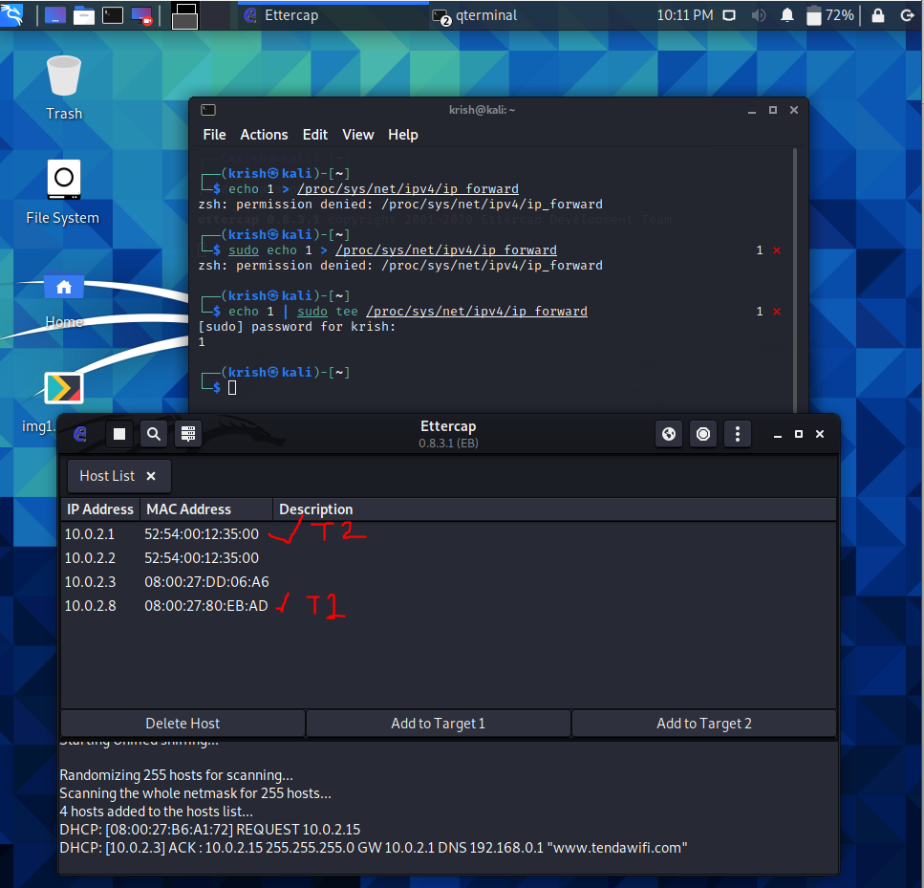

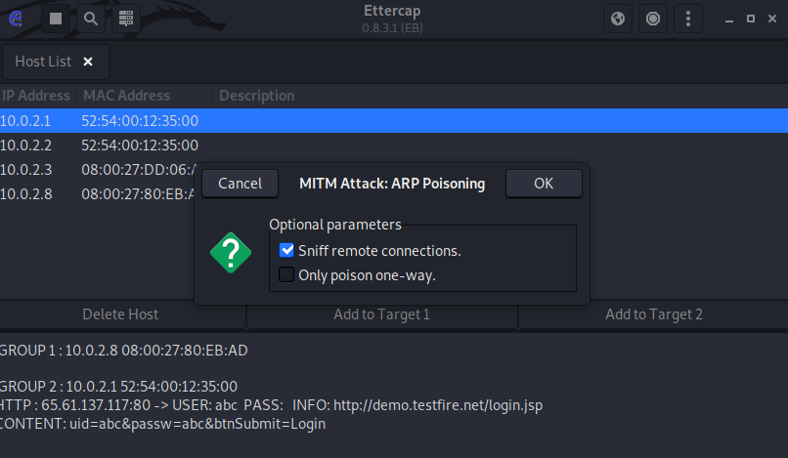

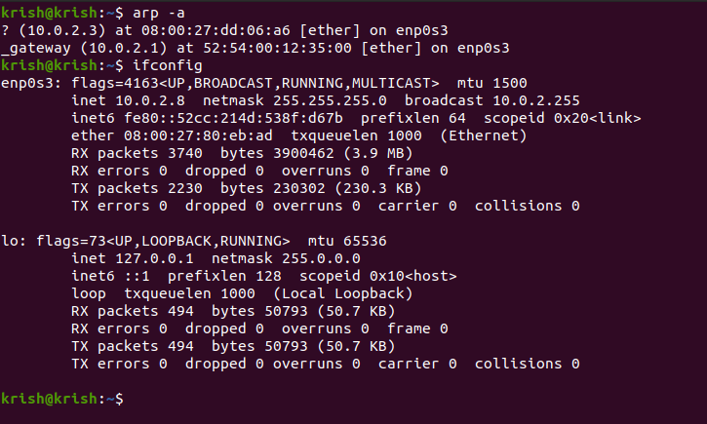

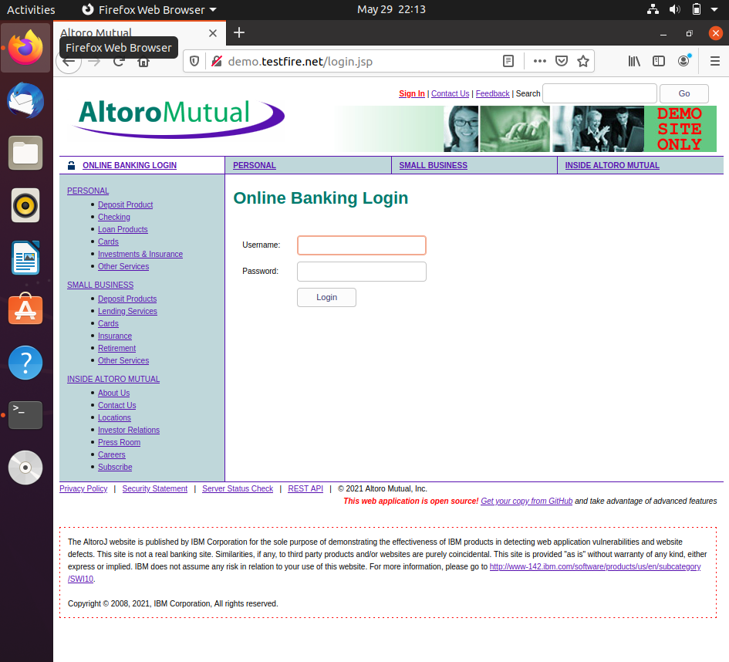

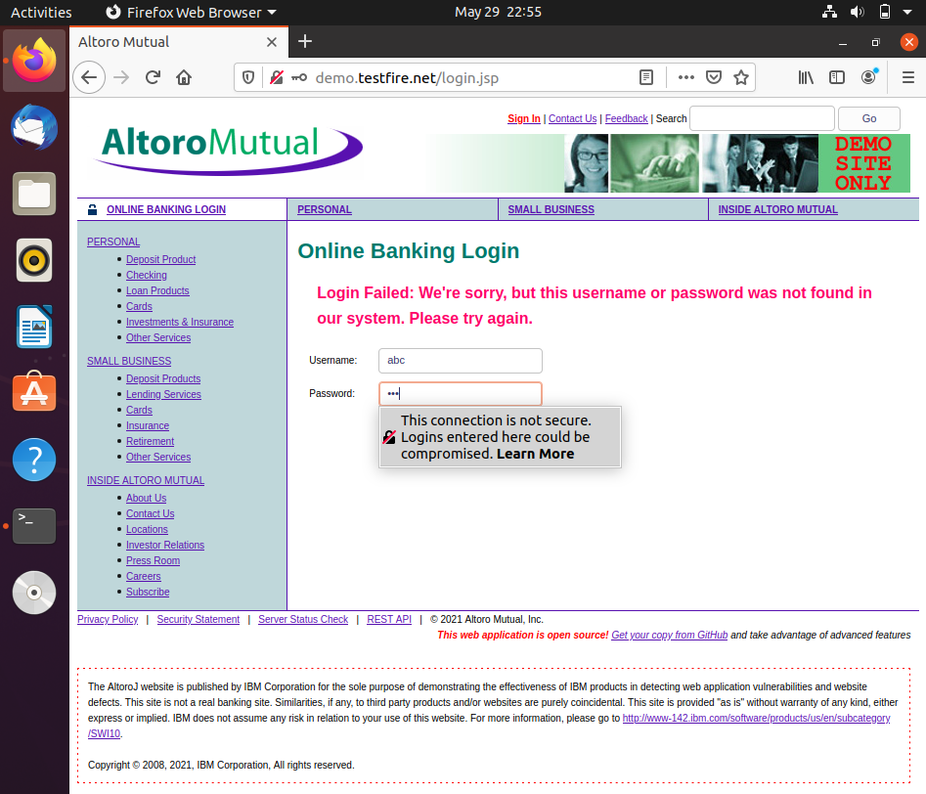

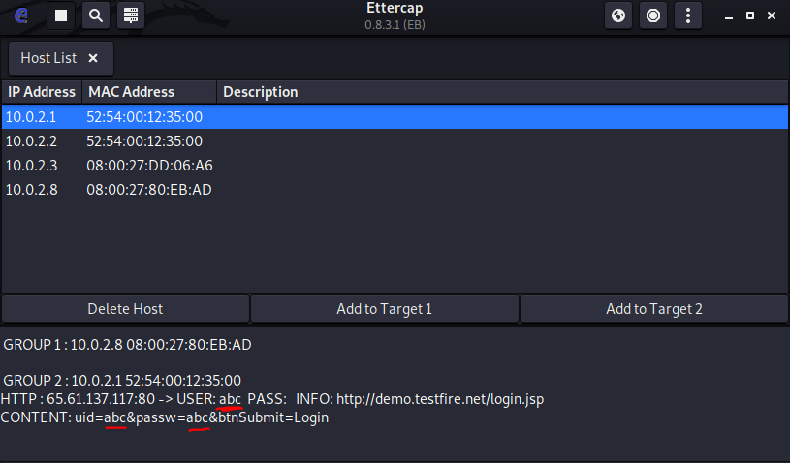

**DNS SPOOFING:**

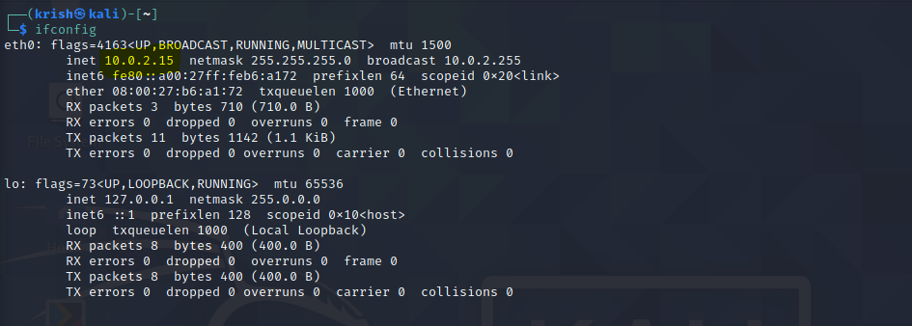

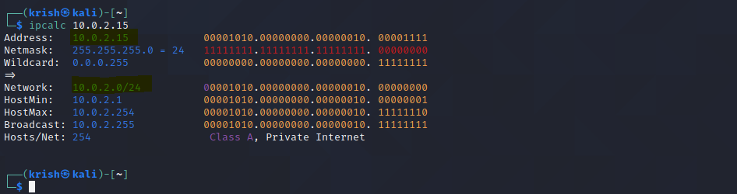

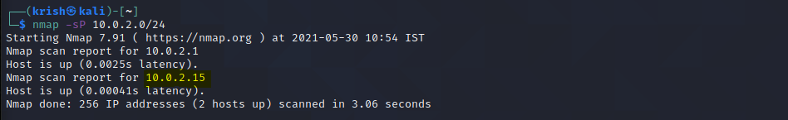

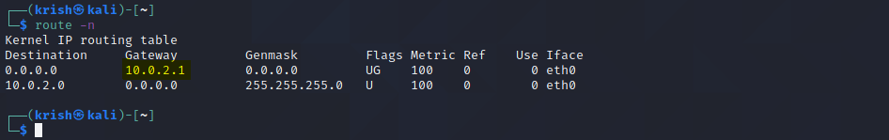

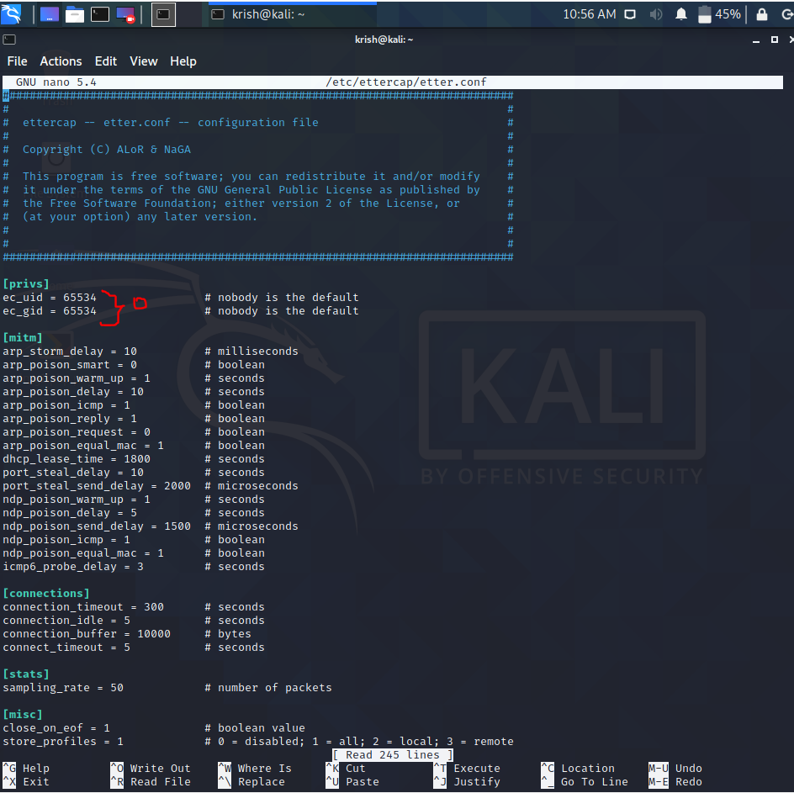

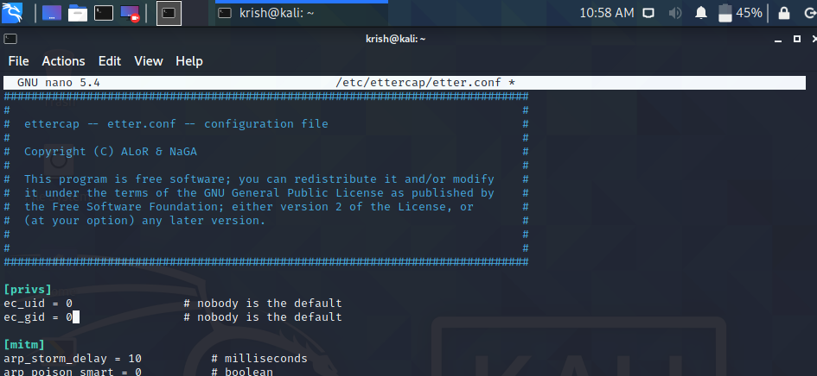

**DOS attack:**

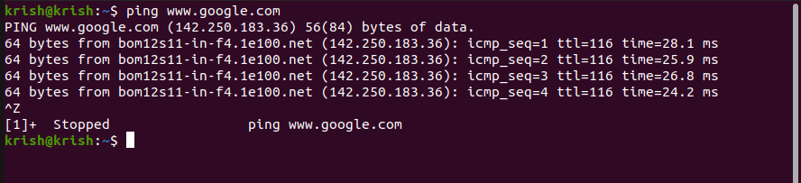

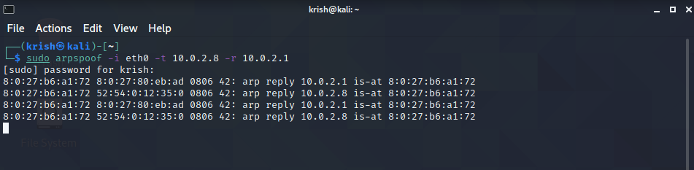

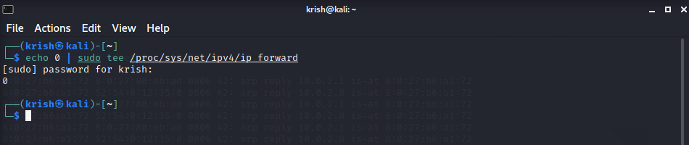

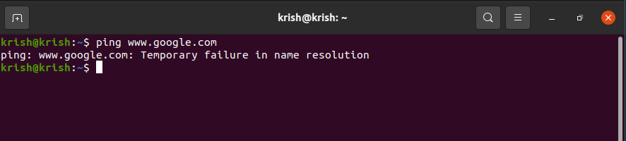

**Detection:**

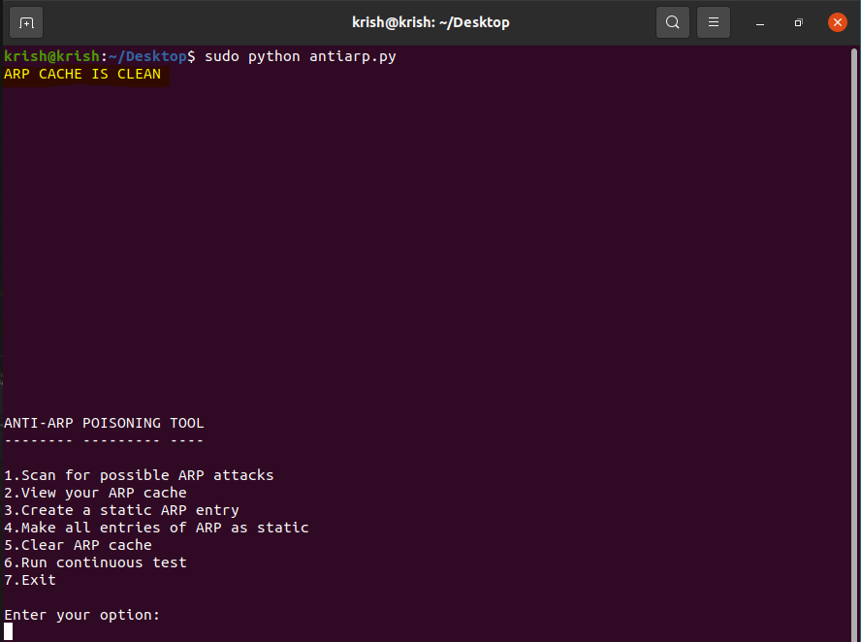

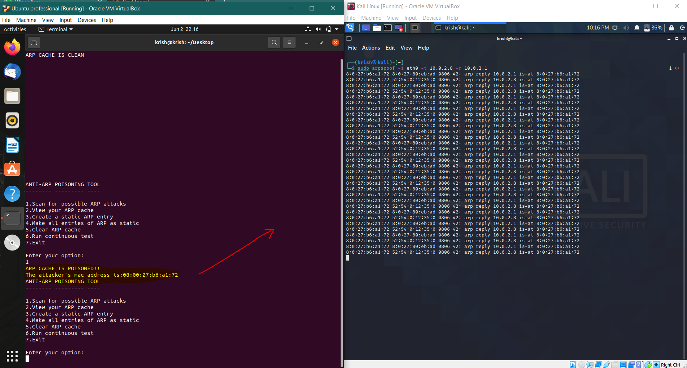

**Prevention:**

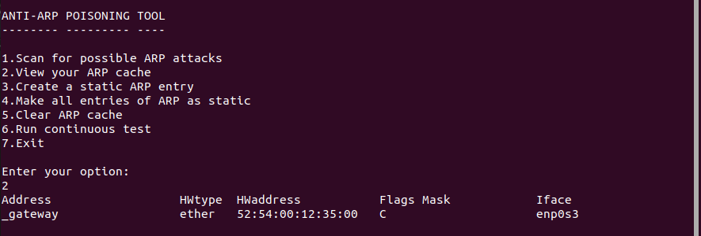

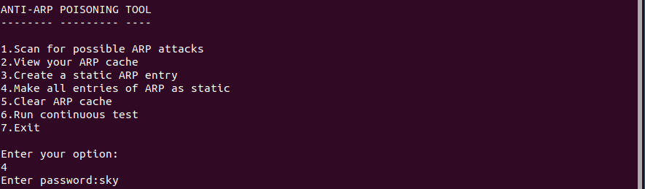

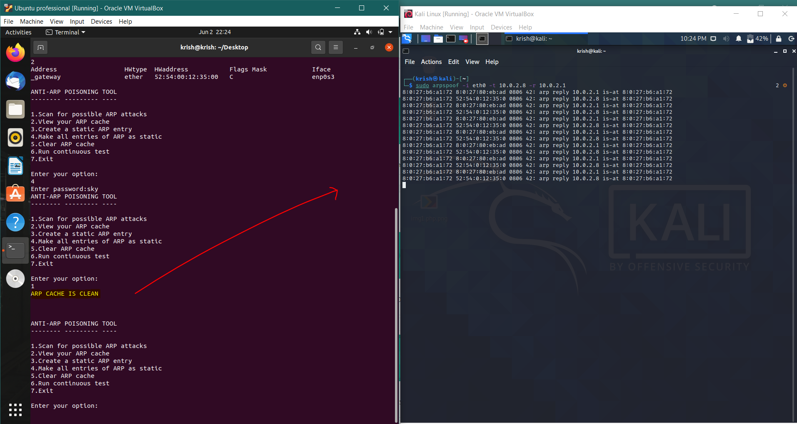

**Recovery:**

